Press Release
December 28, 2015
Miranda Melville
USA Elite Athlete
Race Walk
585-313-2127
FOR IMMEDIATE RELEASE

Miranda Melville Sets New American Record & Wins National Championship Race Walk at RIT
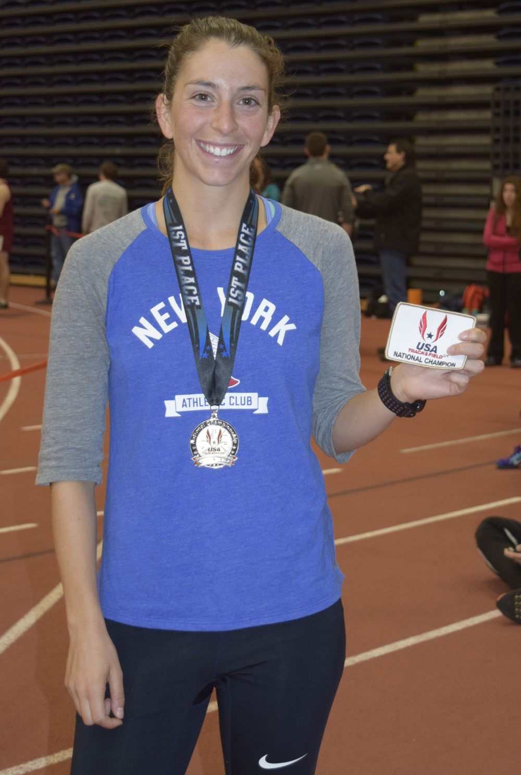
(Sunday, 12/27/2015 Rochester, NY) 2015 National 20K Champion and Rush-Henrietta graduate Miranda Melville of the NYAC won the women’s USATF 5K National Race Walk Championship at the USATF Upstate Holiday Classic held at the Rochester Institute of Technology’s Gordon Field House. Her time of 22:39.53 not only earned her a 9th National Title, it's also a new American Record (AR) and a new meet record. Her coach, 2x Olympian Tim Seaman's response to the news, “Perfect!”.
Melville, who has the Olympic standard going into the 2016 season, also qualified for the USATF Indoor National Championships to be held in Portland Oregon in March.

2015 has been a good year for Miranda, winning gold at the USA Outdoor Nationals in Eugene June and the 15K Nationals in Riverside CA in May, 2nd at at world Cup Trials in New Jersey and Indoor Nationals in the spring, 10th at Toronto Pan Am Games in July, and 26th at World Games in Beijing China in August. Melville was a National 10K Race Walk Junior Champion (2008), and Silver medalist at 2012 20K Race Walk Olympic Trials.

Miranda said “I love racing at RIT. It is a track I grew up on and it always brings back great memories. This result just makes me excited for the 2016 season”. Miranda is also a grant recipient of the Greater Rochester Amateur Athletic Federation (GRAAFUSA.org). # # #

